Chapter 5, Solution 53.

(a)
−+
+
v_{o}
R₂
v₁
R₁
R₂
v₂
R₁
v_{b}
v_{a}

At node a,
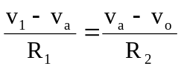 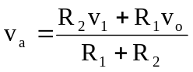 (1)
At node b, 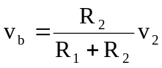 (2)

But v_{a} = v_{b}. Setting (1) and (2) equal gives
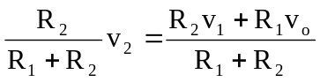
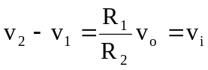
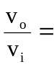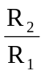

(b)
−+
+
R₂
R₁/2
v₂
R₁/2
v_{A}
v_{B}
v_{a}
v_{b}
−
v_{i}
+
+
v_{o}
−
R_{g}
R₂
v₁
R₁/2
R₁/2

At node A, 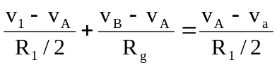

or 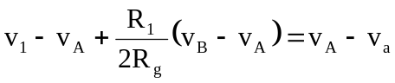 (1)

At node B, 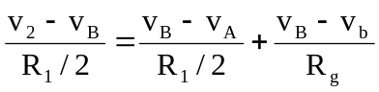

or 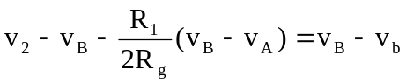 (2)

Subtracting (1) from (2),

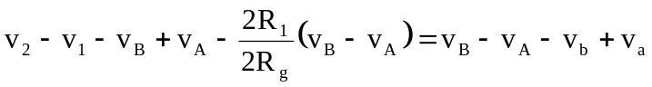
Since, v_{a} = v_{b},
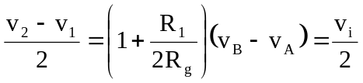

or 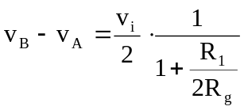 (3)

But for the difference amplifier,

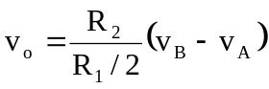
or 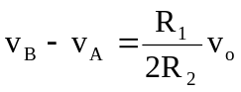 (4)

Equating (3) and (4), 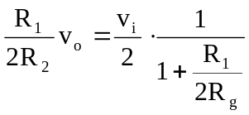
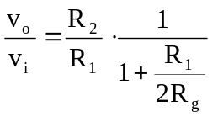

(c) At node a, 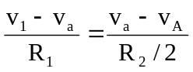
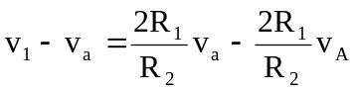 (1)
At node b, 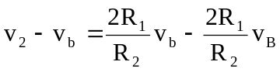 (2)

Since v_{a} = v_{b}, we subtract (1) from (2),

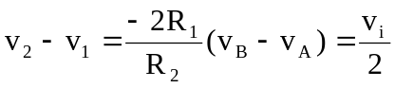
or 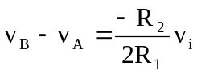 (3)

At node A,

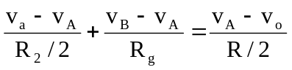
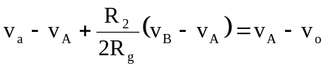 (4)

At node B, 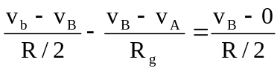
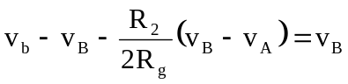 (5)
Subtracting (5) from (4),
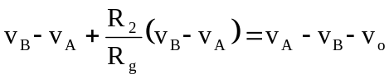
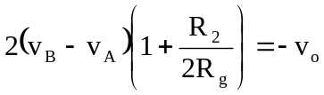 (6)
Combining (3) and (6),
